OH&S Induction E-learning Module for HACC Field Staff

Document 4 – Information for Workers/ Volunteers

Ageing, Disability and Home Care (ADHC) has developed an online e-learning module to assist Home and Community Care (HACC) workers and volunteers complete an Occupational Health and Safety (OH&S) induction. A trial OH&S Induction e-learning module has been established as a new way to complete this training.

<insert name of the agency/organisation> is participating in this trial. Your supervisor will provide you with the necessary information and material required for you to complete the course which may include a quick lesson in how to use a mouse (see attachment A) and put a website address into an internet web browser (e.g. Internet Explorer, Firefox etc).

Options for accessing the internet should be discussed with your supervisor. If you do not have access to the internet at home, public libraries and commercial internet access points (internet cafes) provide online access.

The module will take anywhere between 1-2 hrs. If you have reasonable PC skills and are used to reading material on a screen it should take you less time, if not you should plan for a longer timeframe.

To complete the module you need to do the assessment at the end. There is not a limit on the number of attempts you make to complete the assessment. If you get interrupted you can close the program and come back later where you will be able to continue from the last screen you were on.

The module has all the information on the screen and if you move your mouse over the ‘Tips’ and ‘Notes’ boxes further information will appear on the screen. Clicking on the blue text will open documents with further information about the topic you are reading.

At the completion of the program you will be asked for verification that you have viewed all screens and completed the module. You will then be asked to enter your name and location. This information will go on a certificate confirming you have completed the module. You will also be asked to provide the following information:
- name of agency [insert title of agency]
- name of Local Planning Area [insert your LPA]
- supervisor e-mail address [insert supervisor’s e-mail

Your Supervisor may give you support material which will include:
- workplace/home safety check form x 2 (needed to complete the case study exercise)
- hazard form
- pair of gloves
- agency material about manual handling (optional)
- agency OH&S material for OH&S Induction (optional)
- earphones to hear the voice over (optional)

When you complete the module a meeting between you and your supervisor should be scheduled.
At the meeting you will need:
- to hand in the Workplace/Home Safety check example done for the e-learning module
- to demonstrate the safe removal of the gloves.

At the meting your supervisor will:
- provide feedback about the completed Workplace/Home Safety check example
- go through local procedures for hazard identification including the hazard exercise
- identify any other local practices related to OH&S including consultation arrangements
- confirm completion of the module by slighting the certificate of completion or confirm they have received the confirmation e-mail
- answer any general questions and arrange for any reimbursements.

How to access the OH&S Induction e-learning module
The module is available at http://www.elearn.com.au/hacc

When you get to a computer with internet access you need to:
- open the web browser (double click on the icon of Internet Explorer or Firefox etc)

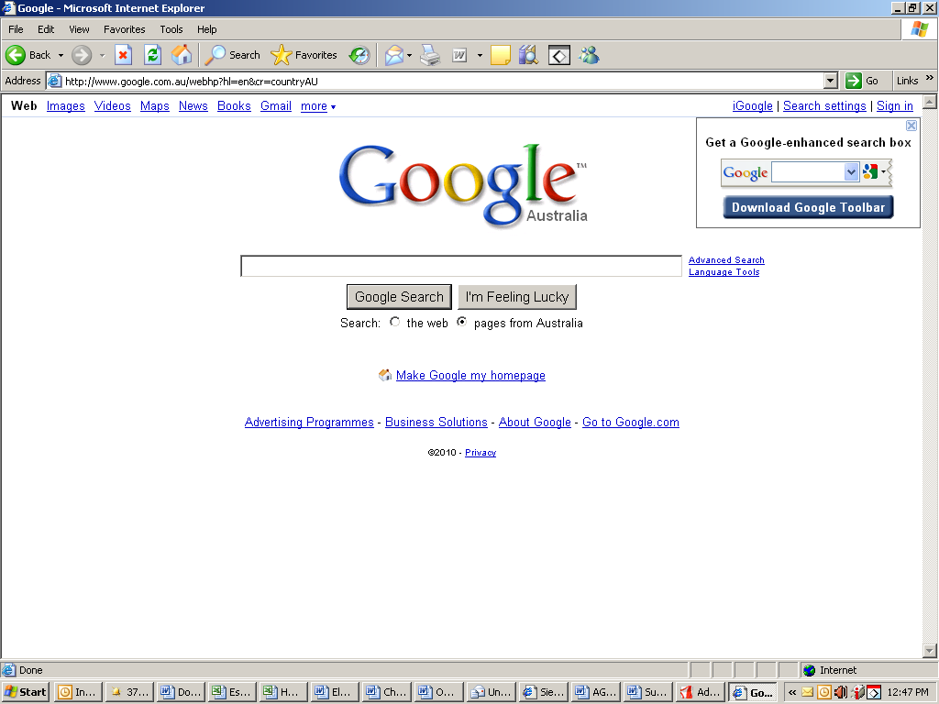
STEP 1

Delete what is in the address line and type in the address provided
http://www.elearn.com.au/hacc

- delete the current address in the address field
- type exactly as it is written the following http://www.elearn.com.au/hacc
- press the Enter key on the keyboard.

This will bring up a box asking you to type in a username and password

Username: hacc Password: training (lower case, no capitals)
Click OK or press ENTER key

This should open up the program. Which will look like this…. and this

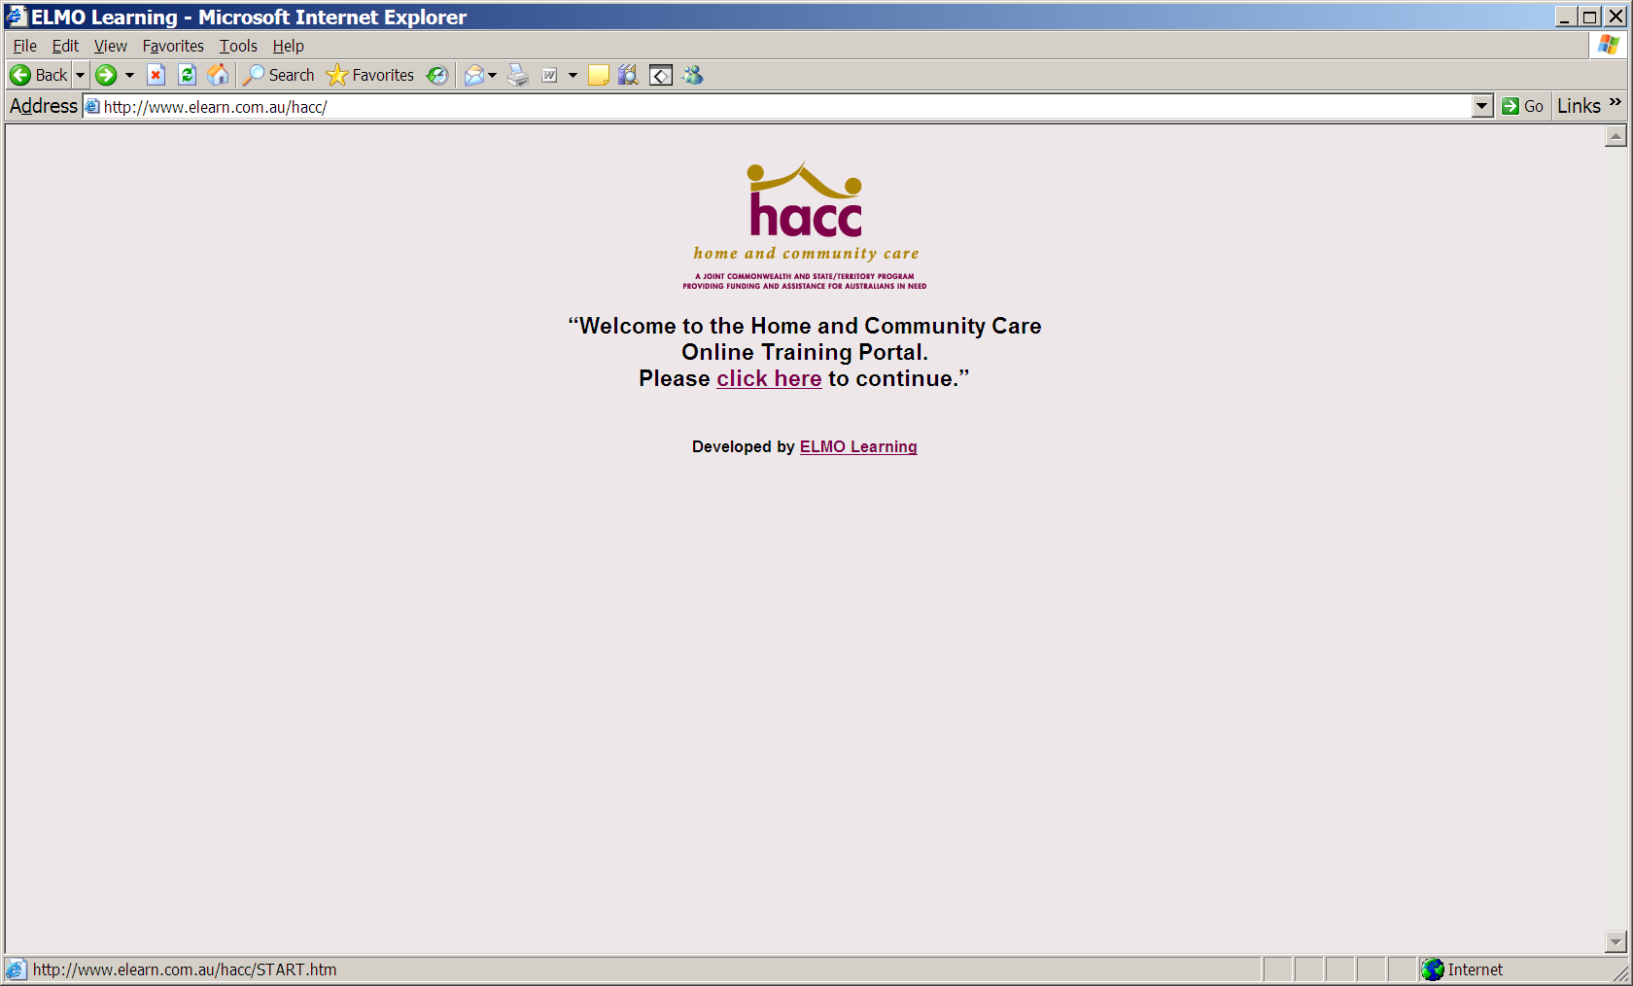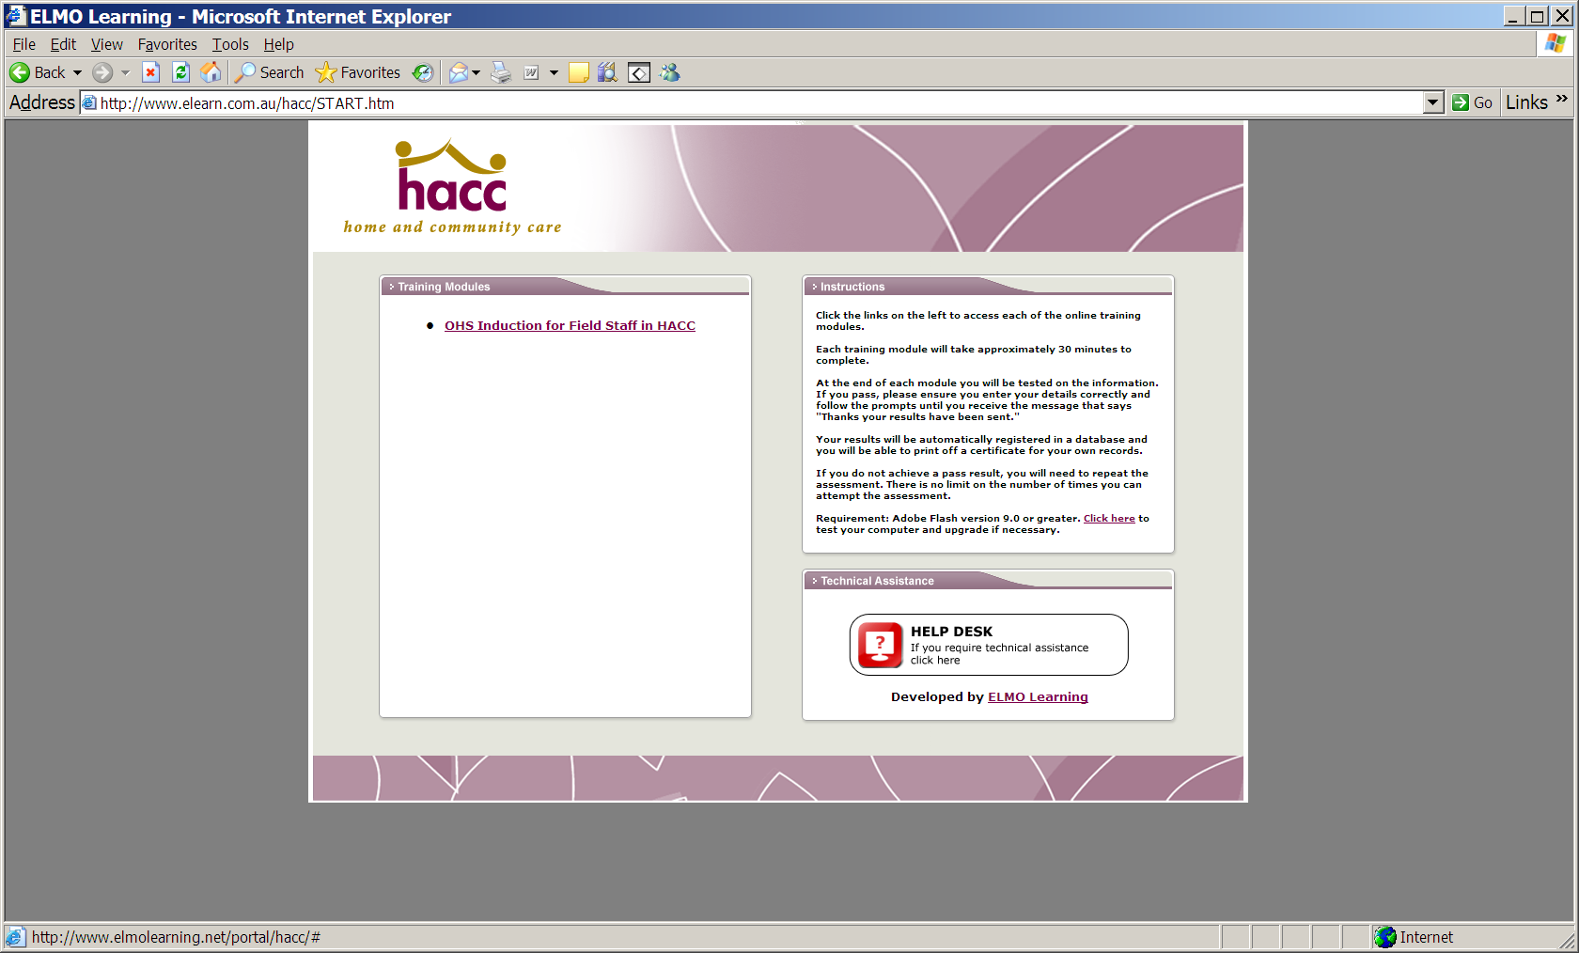

Follow the on screen instructions. The earphone jack plugs into the audio hole in the computer which may be on the back or front of the computer box. The PC may also have speakers.


Attachment A - How to Use Your Computer Mouse
The computer’s mouse controls a graphical mouse pointer or mouse cursor on the screen. When you move the mouse around by rolling it on your desk, the pointer on the screen moves in a similar manner. Roll the mouse left, and the pointer moves left; roll it in circles, and the pointer mimics that action.
Here are some of the more basic mouse operations:
- Point: When you’re told to “point the mouse,” you move the mouse on the desk or pad which moves the mouse pointer on the screen to point at something interesting (or not).
- Click: A click is a press of the mouse button — one press and release of the main button, the one on the left. This action makes a clicking sound, which is where this maneuver gets its name.
Clicking is often done to select something or to identify a specific location on the screen.

NEARLY ALL THE TASKS REQUIRED FOR YOUR E-LEARNING MODULE ONLY REQUIRE ONE CLICK

- Double-click: This one works just like the single click, although you click twice in the same spot — usually, rather rapidly to open other documents or programs.

Hazard Identification Exercise For Field Staff
As part of OH&S Induction E-learning Module

Complete this Exercise Prior to Seeing your Supervisor

Beatrice and Bertha are twins and they each provide a domestic assistance service to Mrs Elias.

Beatrice goes on Tuesday and Bertha goes on Thursday.

On Tuesday Beatrice goes to Mrs Elias and is cleaning up in the kitchen and is putting the sharp knives away in their holder on the wall. One of the knives falls out and on to the floor between her legs. She puts it back in the holder but notices that it is not holding in position properly but eventually it holds and she finishes her work.

On Thursday Bertha comes for the service and she is putting away the sharp knives. One of them falls out of the holder and stabs Bertha in the top of her foot. There is blood everywhere and Bertha has to go to hospital.

Fill out your Hazard form based on what Beatrice should have done.

